
Solar Monitor
SM2-AD Module Specification

Inputs
2x analog differential | 0 – 10 V, 0 – 20 mA
1x analog unipolar | 0 – 10 V, 0 – 20 mA, 0 – 100 mV, 0 – 20 mV
Outputs
1x analog | 0 – 10 V
2 x relay | 48 V, 3 A
Interface
RS485 | HBUS (DIN rail, bottom pluggable, no external wires needed)
Max. distance | 1200 m
Electrical parameters
Power supply | 12 – 24 V DC, max. 50 mA (DIN rail HBUS)
Mechanical parameters
Dimensions | 35.6 x 89.7 x 62.2 mm
Mounting | DIN rail, wall
Screw terminals | 0.5 mm² – 1.5 mm² cable cores
Protection rating | IP20
Operating temperature | -25 .. +60 °C
LED diodes | Status

Mechanical Dimensions

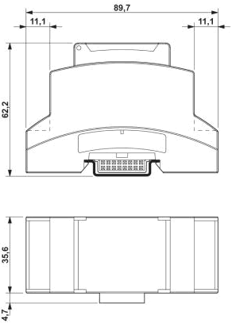

Power supply 12 V.

